**Practical – 4**

**Aim: -** Install and configure both PHP and MySQL.

**What is PHP?**

PHP stands for Hypertext Pre-processor, that earlier stood for Personal Home Pages. PHP scripts can only be interpreted on a server that has PHP installed. The client computers accessing the PHP scripts require a web browser only. A PHP file contains PHP tags and ends with the extension ".php".

**What is XAMPP?**

XAMPP is a cross-platform web server that is free and open-source. XAMPP is a short form for Cross-Platform, Apache, MySQL, PHP, and Perl. XAMPP is a popular cross-platform web server that allows programmers to write and test their code on a local webserver. It was created by Apache Friends, and the public can revise or modify its native source code. It includes MariaDB, Apache HTTP Server, and interpreters for PHP and Perl, among other computer languages. Because of XAMPP’s simplicity of deployment, a developer can quickly and easily install a WAMP or LAMP stack on an operating system, with the added benefit that common add-in apps like WordPress and Joomla can also be loaded.

**Installation of XAMPP Controller**

1. Go to <https://apachefriends.org>.

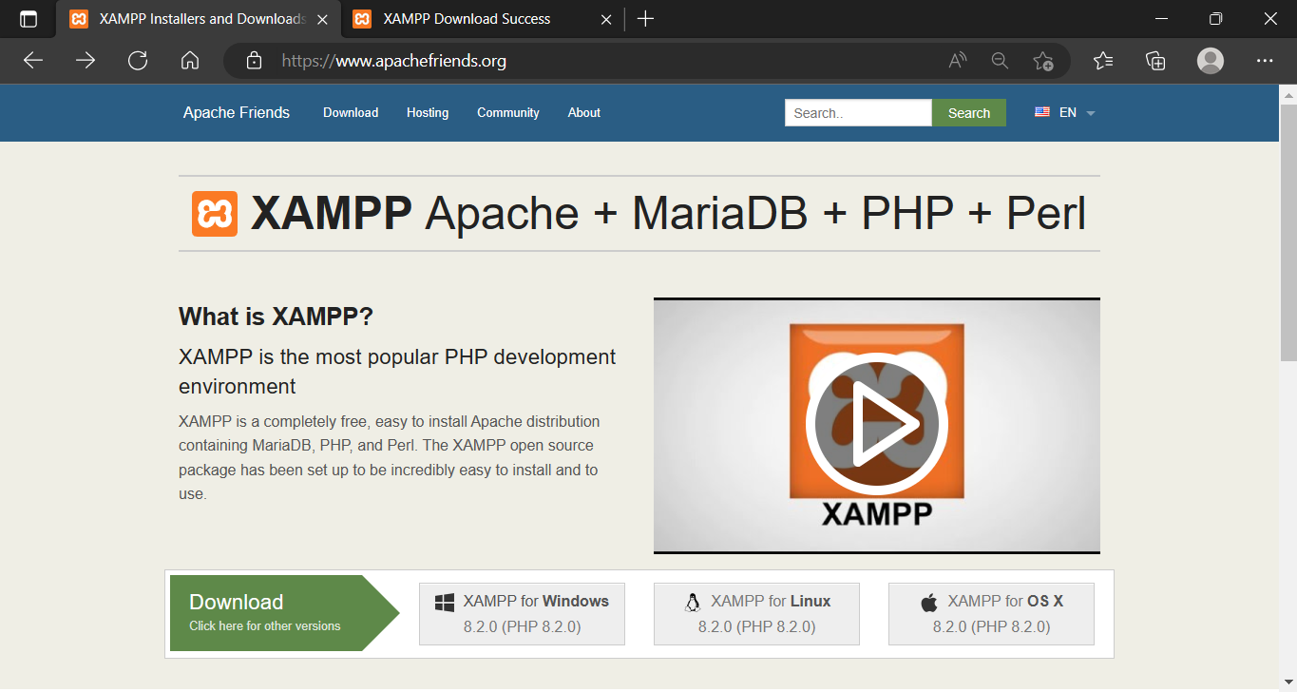

1. On scrolling the page, the download option of Xampp controller is available for different.
2. Select the platform based installer(Linux, Windows, MacOS).

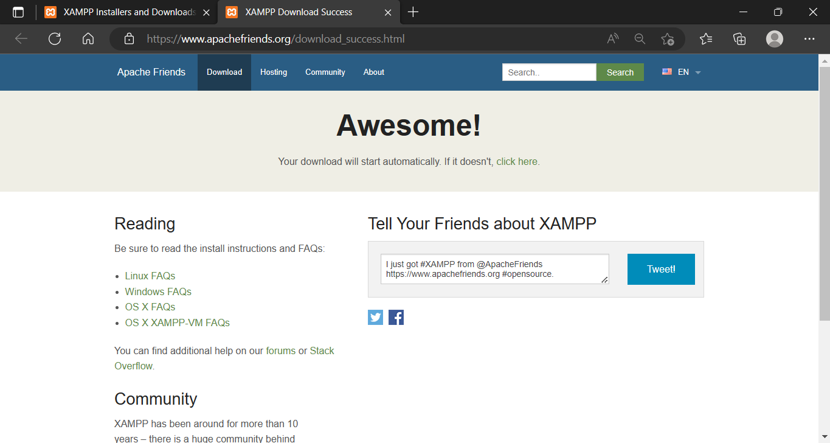

1. And hence, download successful.
2. Open the installer and follow up the next button.

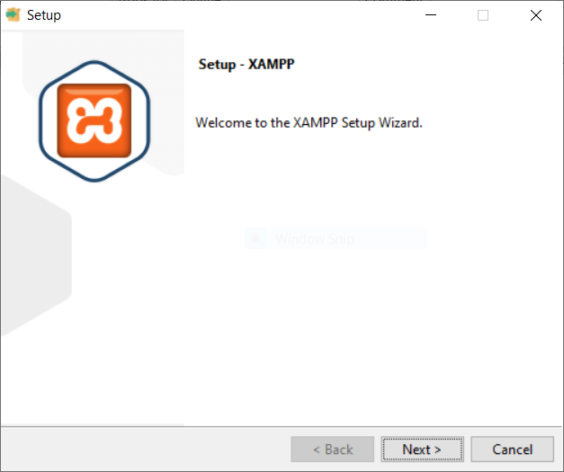

1. Select the component and the services to be installed

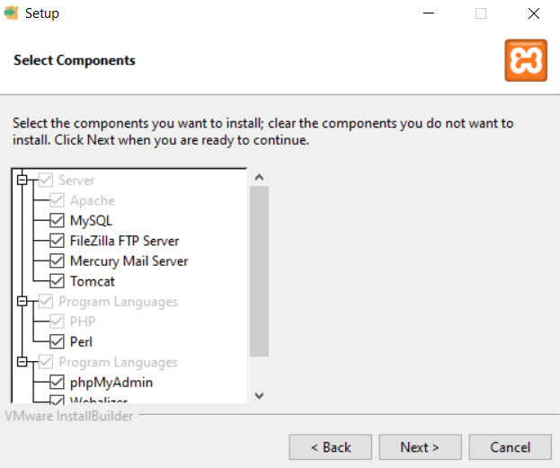

1. Locate the location to be install the XAMPP program and its files

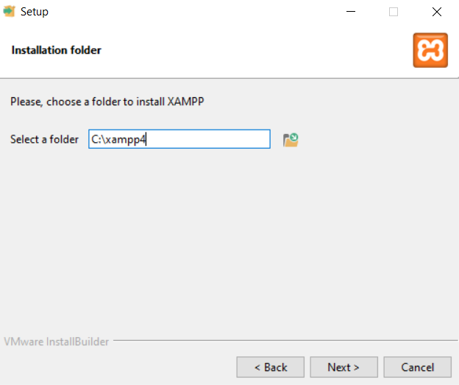

1. Follow up the Next button and at next step select the Language. By Default it is selected English
2. Setup is Ready to install and click the Next button to start the installation

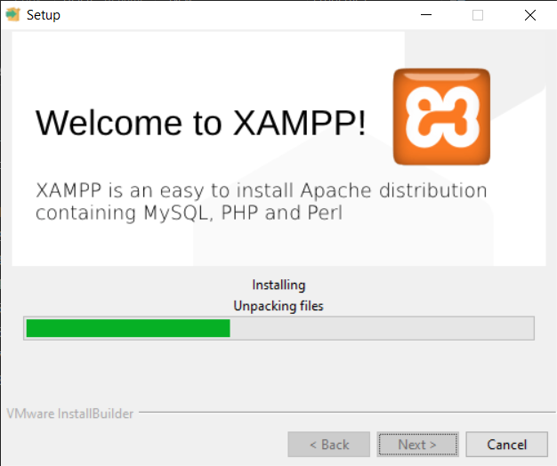

1. Setup successfully installed, Check out the box for start the Xampp control

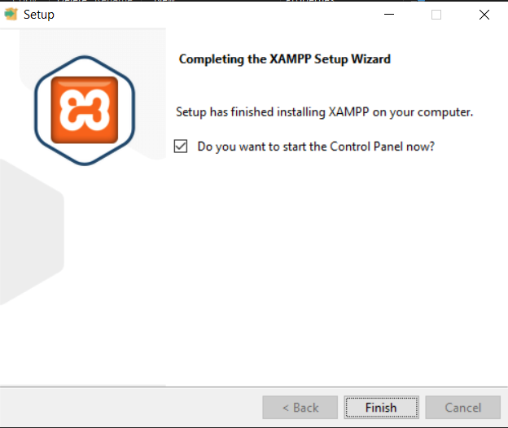

After the installation, all the web page creation are performed in Htdocs folder in the Xampp files

**Starting a Service**

1. Open the XAMPP control.
2. Click on the Start button of Apache and MySQL service
3. Hence we start a local host Server

